APPLICATION FOR EMPLOYMENT
(Pre-Employment Questionnaire) (An Equal Opportunity Employer)
PERSONAL INFORMATION
DATE

NAME
LAST
FIRST
CITY
MIDDLE
STATE
PRESENT ADDRESS
PERMANENT ADDRESS
PHONE NO.
STREET
STREET
ZIP
CITY
STATE
ZIP
ARE YOU 18 YEARS OR OLDER?
Yes ❑
No ❑
ARE YOU PREVENTED FROM LAWFULLY BECOMING EMPLOYED
IN THIS COUNTRY BECAUSE OF VISA OR IMMIGRATION STATUS?
Yes ❑
No ❑
EMPLOYMENT DESIRED
DATE YOU
CAN START
IF SO MAY WE INQUIRE
OF YOUR PRESENT EMPLOYER?
SALARY
DESIRED
POSITION
ARE YOU EMPLOYED NOW?
EVER APPLIED TO THIS COMPANY BEFORE?
REFERRED BY
WHERE?
WHEN?
*NO OF
EDUCATION
HIGH SCHOOL
COLLEGE
NAME AND LOCATION OF SCHOOL
YEARS
*DID YOU
GRADUATE?
SUBJECTS STUDIED
ATTENDED
TRADE, BUSINESS OR
CORRESPONDENCE
SCHOOL
GENERAL
SUBJECTS OF SPECIAL STUDY OR RESEARCH WORK
SPECIAL SKILLS
ACTlVITIES: (CIVIC ATHLETIC ETC.)
EXCLUDE ORGANIZATIONS, THE NAME OF WHICH INDICATES THE RACE, CREED. SEX. AGE, MARITAL STATUS, COLOR OR NATION OF ORIGIN OF ITS MEMBERS.
U. S MILITARY OR
NAVAL SERVICE
PRESENT MEMBERSHIP IN
NATIONAL GUARD OR RESERVES
RANK
*This form has been revised to comply with the provisions of the Americans with Disabilities Act
and the ﬁnal regulations and interpretive guidance promulgated by the EEOC on July 26. 1991.
TOPS FORM 3285 (92-8)
(CONTINUED ON OTHER SIDE)
LITHO IN U.S.A.
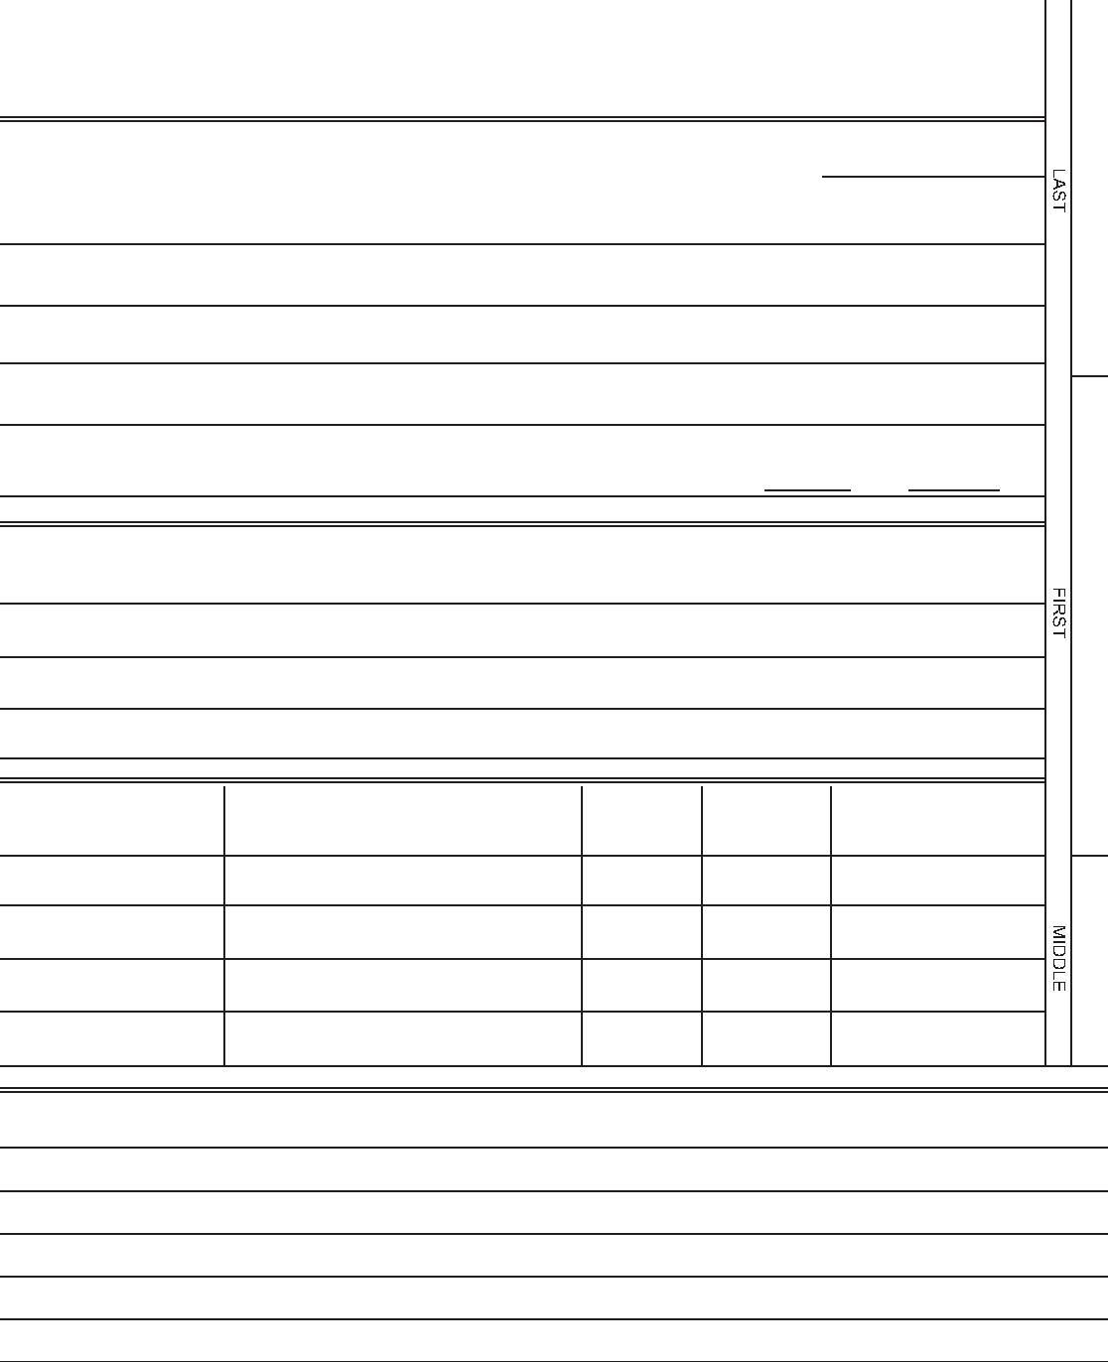

FORMER EMPLOYERS (LIST BELOW LAST THREE EMPLOYERS, STARTING WITH LAST ONE FIRST).
DATE
MONTH AND YEAR
NAME AND ADDRESS OF EMPLOYER
SALARY
POSITION
REASON FOR LEAVING
FROM
TO
FROM
TO
FROM
TO
FROM
TO
WHICH OF THESE JOBS DlD YOU LIKE BEST?
WHAT DlD YOU LIKE MOST ABOUT THIS JOB?
REFERENCES:
GIVE THE NAMES OF THREE PERSONS NOT RELATED TO YOU, WHOM YOU HAVE KNOWN AT LEAST ONE YEAR.
YEARS
NAME
ADDRESS
BUSINESS
ACQUAINTED
1
2
3
THE FOLLOWING STATEMENT APPLIES IN: MARYLAND & MASSACHUSETTS. [Fill in name of state.)
IT IS UNLAWFUL IN THE STATE OF ________________________ TO REQUIRE OR ADMINISTER A LIE DETECTOR TEST
AS A CONDITION OF EMPLOYMENT OR CONTINUED EMPLOYMENT. AN EMPLOYER WHO VIOLATES THIS LAW SHALL
BE SUBJECT TO CRIMINAL PENALTIES AND CIVIL LIABILITY.
Signature of Applicant
IN CASE OF
EMERGENCY NOTIFY
NAME
ADDRESS
PHONE NO.
"I CERTIFY THAT ALL THE INFORMATION SUBMITTED BY ME ON THIS APPLICATION IS TRUE AND COMPLETE, AND I UNDERSTAND THAT
IF ANY FALSE INFORMATION, OMISSIONS, OR MISREPRESENTATIONS ARE DISCOVERED, MY APPLICATION MAY BE REJECTED AND, IF I
AM EMPLOYED. MY EMPLOYMENT MAY BE TERMINATED AT ANY TIME.
IN CONSIDERATION OF MY EMPLOYMENT, I AGREE TO CONFORM TO THE COMPANY'S RULES AND REGULATIONS, AND I AGREE THAT
MY EMPLOYMENT AND COMPENSATION CAN BE TERMINATED, WITH OR WITHOUT CAUSE. AND WITH OR WITHOUT NOTICE, AT ANY
TIME, AT EITHER MY OR THE COMPANY'S OPTION. I ALSO UNDERSTAND AND AGREE THAT THE TERMS AND CONDITIONS OF MY
EMPLOYMENT MAY BE CHANGED, WITH OR WITHOUT CAUSE, AND WITH OR WITHOUT NOTICE, AT ANY TIME BY THE COMPANY. I
UNDERSTAND THAT NO COMPANY REPRESENTATIVE, OTHER THAN IT'S PRESIDENT, AND THEN ONLY WHEN IN WRONG AND SIGNED
BY THE PRESIDENT, HAS ANY AUTHORITY TO ENTER INTO ANY AGREEMENT FOR EMPLOYMENT FOR ANY SPECIFIC PERIOD OF TIME,
OR TO MAKE ANY AGREEMENT CONTRARY TO THE FOREGOING.
DATE
SIGNATURE
DO NOT WRITE BELOW THIS LINE
INTERVIEWED BY:
REMARKS:
DATE:
NEATNESS
ABILITY
HIRED:
❑Yes ❑No
POSITION
DEPT.
3
SALARY/WAGE
APPROVED:
DATE REPORTING TO WORK
1.
2.
EMPLOYMENT MANAGER
DEPT. HEAD
GENERAL MANAGER
This form has been designed to strictly comply with State and Federal fair employment practice laws prohibiting employment discrimination. This Application for Employment Form
is sold for general use throughout the United States. TOPS assumes no responsibility for the inclusion in said form of any questions which, when asked by the Employer of the
Job Applicant, may violate State and/or Federal Law.

